**The Next door Millionaire.**

**Overview**

1. One of the reasons that millionaires are economically successful is that they think differently
2. Even most multimillionaires in America don’t live in expensive homes.
3. “About one-half of the millionaires in America don’t live in upscale neighborhoods.”
4. the large majority of the rich live well below their means.
5. constantly setting economic goals and the great happiness gained from achieving them

**Introduction:**

1. Many people who live in expensive homes and drive luxury cars do not actually have much wealth. Many people who have a great deal of wealth do not even live in upscale neighborhoods.
2. Wealth is not the same as income. If you make a good income each year and spend it all, you are not getting wealthier. You are just living high.
3. Wealth is what you accumulate, not what you spend
4. Wealth is seldom luck or inheritance or advanced degrees or even intelligence that enables people to amass fortunes.
5. *Wealth is more often the result of a lifestyle of hard work, perseverance, planning, and, most of all, self-discipline.*
6. Wealthy people could maintain their current lifestyle for years and years without earning even one month’s pay. But normal people can do it for few months.
7. They did it slowly, steadily, without signing a multimillion-dollar contract with the Yankees, without winning the lottery, without becoming the next Mick Jagger.
8. Usually the wealthy individual is a businessman who has lived in the same town for all of his adult life. And he has made his money on his own

**Seven characteristics of wealthy man**

1. *They live* ***well below*** *their means.*
2. *They allocate their* ***time, energy****, and* ***money*** *efficiently, in* ***ways conducive to building wealth****.*
3. *They believe that* ***financial independence*** *is more important than displaying high social status.*
4. *Their* ***parents*** *did* ***not*** *provide economic* ***outpatient care****.*
5. *Their adult* ***children*** *are economically* ***self-sufficient****.*
6. *They are proficient in* ***targeting market opportunities.***
7. *They chose the right* ***occupation****.*

**The research**

Mainly building the wealth takes

* 1. Discipline,
  2. Sacrifice, and
  3. Hard work.

**1, Meet the millionaire next door.**

* They don’t look like millionaires,
* they don’t dress like millionaires,
* they don’t eat like millionaires,
* they don’t act like millionaires
* they don’t even have millionaire names.

*But the fact is they are* ***millionaires****.*

**Big Hat No Cattle**

* *Being simple is the main thing. You should not have a big hat even though you have more cattle.*
* *You may look like a driver or very simple person. But your way should be optimistic. Be on your own way and choose the efficient way.*

**Portrait of a millionaire**

1. We live well below our means.
2. We wear inexpensive suits and drive American-made cars.
3. Only a minority of us drive the current-model-year automobile.
4. Only a minority ever lease our motor vehicles.

**Sum of income x total earning years / 10 = Networth**

There are three types of **wealth accumulator**.

1. PAW (prodigious accumulator of wealth) - Excess
2. UAW (under accumulator of wealth)
3. AAW (average accumulator of wealth)
4. How much money does it take to maintain the **upper-middle-class** lifestyle of an attorney and his family?
5. How much money is required to maintain the **middle-class** or even blue-collar lifestyle of a mobile home dealer and his family?

**Thoughts of one-generation millionaires.**

1. Most people who become millionaires have confidence in their own abilities.
2. They do not spend time worrying about whether or not their parents were wealthy.
3. They do not believe that one must be born wealthy.
4. Conversely, people of modest backgrounds who believe that only the wealthy produce

millionaires are predetermined to remain non-affluent.

*First-generation Americans tend to be* ***self-employed****. Self-employment is a major positive correlate of wealth.*

**2, Frugal Frugal Frugal**

1. The opposite of frugal is wasteful. We define wasteful as a lifestyle marked by lavish spending and hyperc onsumption.
2. The spend very less amount on **clothing**. Fifty percent or more of the millionaires surveyed paid $399 or less for the most expensive suit they ever purchased.
3. Jhony , a self made millionaire doesn’t want to show his employees that he is rich by wearing **costly dresses.** He is simple in his way of dressings.
4. They don’t spend too much on Footwear too.
5. Jhony, looks simple even though he is a millionaire, Perhaps it’s because he and his family don’t look affluent, dress like the affluent, drive the vehicles of the affluent, or work in high-status positions.
6. Neighbour of Johny’s house doesn’t know that Johnny is financially independent.
7. Most people will **never become wealthy** in one generation if they are **married to** people who are **wasteful**

**A Common opinion**

When we tell our audiences about the budgeting and planning habits of the affluent, someone always asks a predictable question:

Why would someone who is a millionaire need to budget? Our answer is always the same:

*“They became millionaires by budgeting and controlling expenses, and they maintain*

*their affluent status the same way”*

***Practical example***

People who are doing jogging daily seems as not to do jogging tomorrow. But if they skip, then they won’t be fit.

Same is applicable for the **affluent**. The should maintain their economy, budgeting and control expenses.

Most people knew the steps and ideas to be fit. But they are not fit enough, because they don’t have the discipline to follow the steps the knew already. If you want to be financially wealthy, you should follow the **financial discipline**.

**QUESTION 1: DOES YOUR HOUSEHOLD OPERATE ON AN ANNUAL BUDGET?**

**QUESTION 2: DO YOU KNOW HOW MUCH YOUR FAMILY SPENDS EACH YEAR FOR FOOD, CLOTHING, AND SHELTER?**

**QUESTION 3: DO YOU HAVE A CLEARLY DEFINED SET OF DAILY, WEEKLY,**

**MONTHLY, ANNUAL, AND LIFETIME GOALS?**

**QUESTION 4: DO YOU SPEND A LOT OF TIME PLANNING YOUR FINANCIAL FUTURE?**

*Financially independent people are happier than those in their same income/age cohort*

*who are not financially secure.*

**Our friend the UAW**

1. he buys more and more via credit, By increasing the amount he owes, he correspondingly increases the accountant’s fear of default.
2. In turn, this increasing level of debt-based fear encourages him to workharder and more aggressively.
3. To him, a big home is a reminder of a big mortgage and the need to perform at a high level ( A middle class mindset )
4. A rich but poor man,

* **Mr. Friend** never really enjoys his life.
* He owns a lot of upscale things, yet he works so hard and for so many hours during a typical day that he has no time to enjoy them.
* He has no time for his family, either.
* He leaves his house each day before dawn and rarely returns home in time for dinner.

**Remember the quote**

“*One earns to spend.*

*When you need to spend more, you need to earn more* “

**THE ULTIMATE CONSUMPTION CATEGORY**

**“***To build wealth, minimize your realized (taxable) income and maximize your unrealized*

*income (wealth/capital appreciation without a cash flow).***”**

You should be a millionaire, Instead, he is on the perpetual earn-and-consume treadmill.

**Financial Independence**

1. It takes planning and sacrificing.
2. Your plan should be to sacrifice high consumption today for financial independence tomorrow

Important rule.

“*If you’re not yet wealthy but want to be someday,* ***never purchase a home*** *that requires a*

*mortgage that is more than twice your household’s total annual realized income*”

**Tips.**

1. Living in less costly areas can enable you to spend less and to invest more of your income.
2. You will pay less for your home and correspondingly less for your property taxes.
3. Your neighbors will be less likely to drive expensive motor vehicles.
4. You will find it easier to keep up, even ahead, of the Joneses and still accumulate wealth.

**3, Time , energy and money**

*“THEY ALLOCATE THEIR TIME, ENERGY, AND MONEY EFFICIENTLY, IN WAYS*

*CONDUCIVE TO BUILDING WEALTH “*

1. PAWs allocate nearly twice the number of hours per month to planning their financial investments as UAWs do.
2. UAW was afraid and worried about the following two issues.
   1. Experiencing a significant reduction in his standard of living.
   2. Not having an income high enough to satisfy his family’s purchasing habits.
3. Start early and accumulate wealth quickly. Most experts on wealth agree that the earlier one starts investing one’s income, the greater the opportunity to accumulate wealth.

Mr. Denzi, for example, is a business owner with two years of technical school training in data processing.

He started working and building wealth at the age of **twenty-two**. Today, **thirty** years later, he has benefited greatly from the meteoric increase in the value of his pension plan.

**“*Begin earning and investing early in your adult life*”**

1. Many of these callers assume that people in upscale areas have money to invest.
2. In reality, manypeople who live in luxury have little money left over after funding their high-consumption lifestyles.

**PAW** know that

1. ***planning,***
2. ***budgeting, and***
3. ***being frugal***

are essential parts of building wealth, even for very high-income producers.

**if you’re not financially independent, you will spend an increasing amount of your time and energy worrying about your socioeconomic future.**

Every one should ask these 3 questions

1. *Do you know how much your family spends each year for food, clothing, and shelter?*
2. *Do you spend a lot of time planning your financial future?*
3. *Are you frugal?*

*To become wealthy we need some investment, But as a middle class guy the only investment method we have is to “****save****”.*

1. live well below their means
2. Plan for the spending on your budget

“*Only those clients with considerable wealth want to know exactly how much their family*

*spends on each and every category.*”

**CAR-SHOPPING METHODS**

“*There is an inverse relationship between* ***the time spent purchasing luxury items*** *such as*

*cars and clothes and the* ***time spent planning one’s financial future****.*”

“It is difficult to accumulate wealth if you spend much of your time, energy, and money for a so-called dealer cost price on an extremely expensive motor vehicle.”

While purchasing , buy an old vehicle with very less money. Don’t love vehicles too much. Because these are the factors which eat our money too much.

Then I just asked myself a simple question: Is the “pride of new car ownership”—and

that’s all it is, pride—worth $20,000? The cars are the same. The answer is no. The “pride

of new car ownership” is not worth $20,000.

**Pride is not worth of 20000**

**FEARS AND WORRIES**

1. Place much less priority on standard-of-living issues.
2. Children of the millionaire are comparatively more frugal, well planned and disciplined.
3. PAWs tend to produce children who become PAWs.

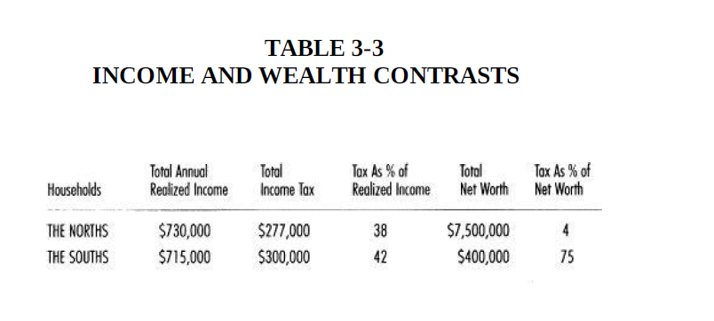

Even most high-income earning employees are consumption-oriented.

You should think on the following.

1. I spend a lot of time planning my financial future.
2. Usually, I have sufficient time to handle my investments properly.
3. When it comes to the allocation of my time, I place the management of my own assets before my other activities.

*Planning and wealth accumulation are significant correlates even among*

*investors with modest incomes.*

**Our careers take up all our time.**

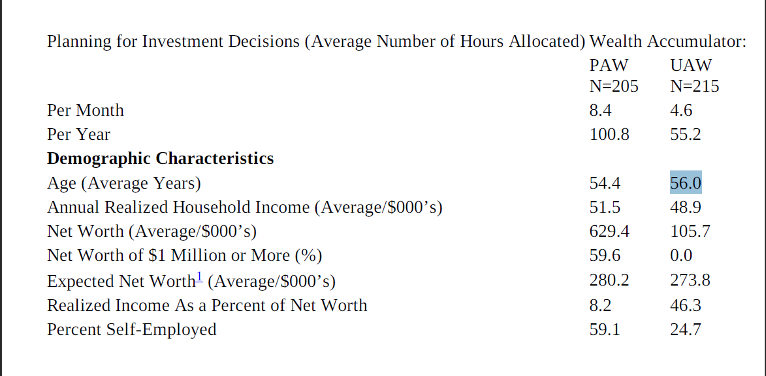

***Actual net worth = 1/ 10 of your age * annual realized house hold income.***

1. UAW usually spend very less time for the investments. They prefer more on cash back ups and quick cash related benefits. They are not interested in Long term benefits.
2. Planning is the foundation of wealth, But UAW doesn’t interested in it.

“Hi, I’m a red-hot potential employee. I can greatly enhance the productivity of any department in which I’m placed. I’m smart, efficient, positive, personable, well groomed, resourceful, and have empathy for the needs of others. When do you want me to start?”

Domestic brands have long been in favor with older millionaires. So buy Indian brands and be cool enough.

**4, YOU AREN’T WHAT YOU DRIVE**

***“THEY BELIEVE THAT FINANCIAL INDEPENDENCE IS MORE IMPORTANT***

***THAN DISPLAYING HIGH SOCIAL STATUS”***

*According to Mr.Allen ( super – PAW) ,*

*“If your goal is to become financially secure, you’ll likely attain it…. But if your motive is to make money to spend money on the good life, … you’re never gonna make it.*”

1. *Many people who never achieve financial independence have a much different set of beliefs. When we ask them about their motives, they speak in terms of work and career.*
2. *They are actually earning to spend, yes just to spend. So they won’t become a millionaire or financial Independence person.*
3. *Who enjoying working? PAWs love working, while a large proportion of UAWs work because they need to support their conspicuous consumption habit.*
   1. *Money should never change one’s values….*
   2. *Making money is only a report card.*
   3. *It’s a way to tell how you’re doing.*

*“Building wealth is not something that will change your lifestyle. Even at this stage of life, I don’t want to change the way I live”*

*If you buy an highly valued thing, you should also buy another things which you really don’t need. So Don’t prefer a rich life style. Actually Prabu ji is doing that thing.*

*Even* ***Mr.Allan*** *have the chance to receive the Rollys Royce car as gift , he refused to get it.*

*Reason : After fishing he will throw the fishes in back seat of his current car. And he will take his boat in the car. In Rolls Royce he can’t do the two things.*

*So he don’t want that car.*

1. *Life has its own burdens. Why add excess baggage like Rolls Royce to it.*
2. *Always prefer less expensive clothes , and less cheap ornaments.*
3. *Make the deal to low as much as possible.*

*The most important thing on* ***vehicle*** *is, betting the very* ***less expensive one****. Be clever on it.*

*“Great offense and poor defense translate into*

*under accumulation of wealth”*

1. UAWs usually think they have more wealth than their neighbors.
2. Many UAWs also believe that people drive the best they can afford.

**4, Economic outpatient care**

Simple rule.

1. It is much easier to spend other people’s money than dollars that are self-generated.
2. We should teach our children how to spend on things.

If you give gifts for your closed ones, then

*“Gift receivers … the adult children of the affluent feel that their parents’ wealth/capital is their income … income to be spent “*

Be concern on gift providing.

“**Whatever your income, always live below your means**”

1. Just be like what you are , shop where you get things in low price and have analysis on these.

The following statement is TRUE in my case.

“The more dollars adult children receive, the fewer dollars they accumulate, while those

who are given fewer dollars accumulate more.”

Discipline and initiatives are must to become wealth. And this is applicable for all the cases.

From sales point of view

“**It’s amazing what you can do when you set your mind to it.**

You’ll be surprised how many sales calls you can make when you have no alternative except to succeed”

**5, AFFIRMATIVE ACTION, FAMILY STYLE**

“THEIR ADULT CHILDREN ARE ECONOMICALLY SELF-SUFFICIENT”

If you depend economically, then you should pay your respect in return. You will feel confident when you have the financial independence.

“*People would be astonished to know how much money I have accumulated…. I know how*

*to hold on to it*”

1. Unemployment during the early stages of adulthood is related to unemployment at later stages in life.
2. *Being in business for myself… When I wake up, every day is a challenge…. I plan my work … work my plan. It’s why my business is a good one.*
3. *Being in business for myself… When I wake up, every day is a challenge…. I plan my work … work my plan. It’s why my business is a good one.*

*RULES FOR AFFLUENT PARENTS AND PRODUCTIVE CHILDREN.*

1. Never tell children that their parents are wealthy.
2. No matter how wealthy you are, teach your children discipline and frugality.
3. Assure that your children won’t realize you’re affluent until after they have established a mature, disciplined, and adult lifestyle and profession.
4. Minimize discussions of the items that each child and grandchild will inherit or receive as gifts.
5. Never give cash or other significant gifts to your adult children as part of a negotiation strategy.
6. Stay out of your adult children’s family matters
7. Don’t try to compete with your children.
8. Always remember that your children are individuals.
9. Emphasize your children’s achievements, no matter how small, not their or your symbols of success.
10. Tell your children that there are a lot of things more valuable than money*.*

* *It’s easier to make money honestly than [dishonestly] in this country. You will never exist in business if you rip people off! Life is the long run.*
* *Good health, longevity, happiness, a loving family, self-reliance, fine friends … if you [have] five, you’re a rich man…. Reputation, respect, integrity, honesty, and a history of achievements!*

**6, Find your niche**

“THEY ARE PROFICIENT IN TARGETING MARKET OPPORTUNITIES”

You are not looking the latest marketing opportunities. You are targeting the customers who are still looking at their price tags.

Change your customers. Look at the larger group of people.

**7, JOBS: MILLIONARES VERSUS HEIRS**

“THEY CHOSE THE RIGHT OCCUPATION”

“*Self-employed people are four times more likely to be millionaires than those who work for others*”

1. The character of the business owner is more important in predicting his level of wealth than the classification of his business
2. **They can take your business, but they can’t take your intellect!**

**Business Owners freedoms.**

1. they have tremendous freedom.
2. They are their own bosses.
3. Also, they tell us that self-employment is less risky than working for others.

*What is risk? Having one source of income.* ***Employees are at risk****…. They have a single*

*source of income. What about the entrepreneur who sells janitorial services to your*

*employers? He has hundreds and hundreds of customers … hundreds and hundreds of*

*sources of income.*

**Benefits on entrepreneur**

1. I’m in control of my own destiny.
2. I can solve any problem.
3. The only way to become a CEO is to own the company.
4. There are no limits on the amount of income I can make.
5. I get stronger and wiser every day by facing risk and adversity.

Multimillionaire’s quote .

*There are more people [employees] today working at jobs that they don’t like. I’ll tell*

*you honestly that the successful man is a guy who works at a job, who likes his work, who*

*can’t wait to get up in the morning to get down to the office, and that’s my criteria. And I’ve*

*always been that way. I can’t wait to get up and get down to the office and get my job under*

*way.*

*“I make money outside of the [equipment] business … in real estate…. God continues to*

*make more people, but he doesn’t make any more land…. You will make money if you’re*

*smart and you’re choosy where you pick the spot”*